

A project paper on

**Autonomous driving LEGO vehicle follower**

Submitted as a requirement of the course

**Real Time Systems**

High Integrity Systems

Winter Semester 2017-2018

Submitted By-

Mohammed Shahed Adnan

Matriculation Nr. : 1179273

Project Group: 18

Under the guidance of –

Prof. Dr. Jens Liebehenschel

Dept. Of Computer Science and Engineering

Frankfurt University of Applied Sciences

**Abstract:**

Autonomous driving assists human to drive safely and with less effort. In traffic, an autonomous driving system manages a vehicle with respect to other vehicles without human intervention. There are many possible scenarios like following a vehicle in forward direction, right turn, left turn etc. One must balance the behavior so that the system always maintains a safety level. At the same time the system should not be so defensive to keep the normal traffic flow.

In this project we are working with two vehicles. First one is controlled with mobile apps via Bluetooth. Second one follows the first one without human intervention in forward direction. When the first vehicle starts moving, the second one also starts moving. When the first one stops, second one also stops keeping a certain distance. During follow up, the second vehicle maintains safety level by speed up and down. In a very low distance, the vehicle stops to avoid unexpected event. Hence, safety issues are ensured during follow up.

**Implementation Ideas:**

There are several ideas to implement the autonomous behavior. In each case distance is an important parameter. We can measure the distance by image processing or using sensor. In this implementation we are measuring distance using ultra sonic sensor. Based on the distance between two vehicles, the second vehicle controls its speed to follow the first vehicle automatically. There are some reasons to choose ultra sonic sensor to measure distance like it can sense all types of materials, sensor works in atmospheric dust, rain, snow, fog etc. Though it has several advantages but due to some disadvantage like difficulties in reading reflection from thin and small object, our autonomous vehicle shows some immature behavior. [1]

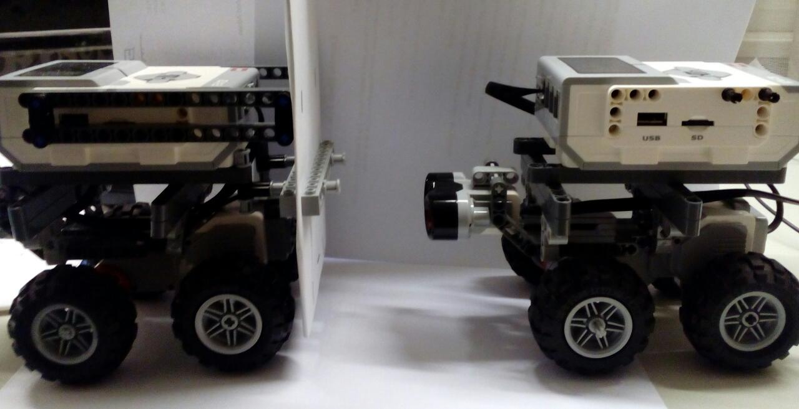

Figure: Autonomous vehicle follower

**Algorithm:**

***Step 1:*** set constant_distance cd, transition_distance td, critical_value

***Step 2:*** turn on Ultrasonic sensor and measure distance

dist= getDistance();

***Step 3:***

**while**(flag!=**false**) {

dist= getDistance();

**if**(dist>*cd*+ *td*) {

**while**(dist>*cd*+ *td*) {

move the vehicle forward;

dist= getDistance();

}

}

**else** **if** (*cd*+ *td* > dist &&dist>*cd*) {

**while**(*cd*+ *td* > dist && dist>*cd*) {

move the vehicle forward slowly;

dist= getDistance();

}

}

**else** **if** (dist== *cd*) {

**while**(dist==*cd*) {

move the vehicle forward in certain distance;

dist= getDistance();

}

}

**else** **if**(*cd*>dist && dist>*critical_value*) {

**while**(*cd*>dist && dist>*critical_value*) {

move the vehicle forward very slowly;

dist= getDistance();

}

}

**else** **if**(dist<*critical_value*) {

**while**(dist<*critical_value*) {

stop the vehicle and wait for next action;

dist= getDistance();

}

}

**if**(dist<.05) {flag=**false**;**break**;} // to avoid collision

}

**Details of Implementation:**

In step 1, we calculate the distance using ultrasonic sensor and store the value in a variable dist. We are using three variable named constant_distance(cd), transition_distance(td) and critical_value. To control the speed we are setting the values of these three variable as cd = 15 cm, td = 20 cm and critical_value= 10cm.

In the next step, follower (2nd vehicle) vehicle moves forward and depending on the distance it changes state. When the distance is greater than transition distance plus constant distance, follower vehicle moves forward in normal speed. We are using 300 rpm in this condition.

When the distance is greater than constant distance but less than constant distance plus transition distance, follower vehicle can sense that there is a vehicle in a near distance and slows down speed by 200 rpm. If the distance is equal to constant distance then the vehicle runs at the same speed of the first vehicle. We guess this speed is 100 rpm.

When the distance is less than constant distance but greater than critical value, the follower vehicle realize that the first vehicle is either stopped or moving slowly. Hence it also moves forward very slowly, basically in 50 rpm. If the distance is less than critical value then the follower vehicle stops because it can sense that the first vehicle is not moving. As soon as the first vehicle starts moving, the follower vehicle also starts moving forward and adjust the speed depending on the distance from first vehicle.

At any time, if we want to stop the autonomous following behavior, press down in ESCAPE button enables us to do that. Moreover, we have a safety condition which is used to stop the vehicle in special cases. For example, somehow the system crashed, on that time a distance less than 5 cm is used to prevent the vehicle from collision. Another case, if someone tries to pass the road in front of the vehicle, then a distance less than 5 cm also save the person from accident. Because the vehicle stops automatically whenever this unexpected distance is measured. The following figure depicts the whole scenario-

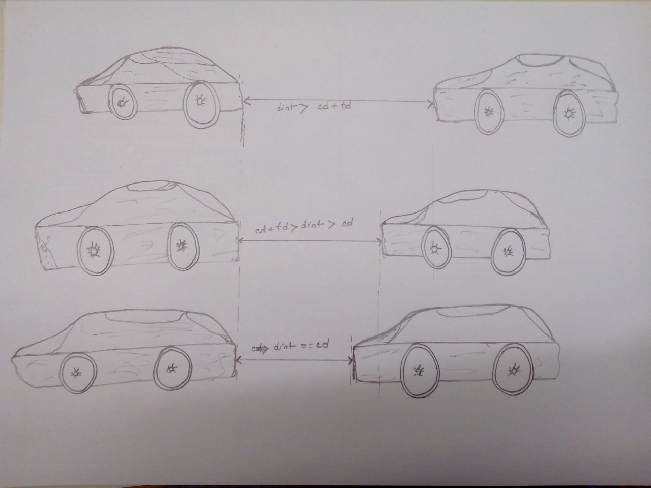

Figure: Vehicle Position

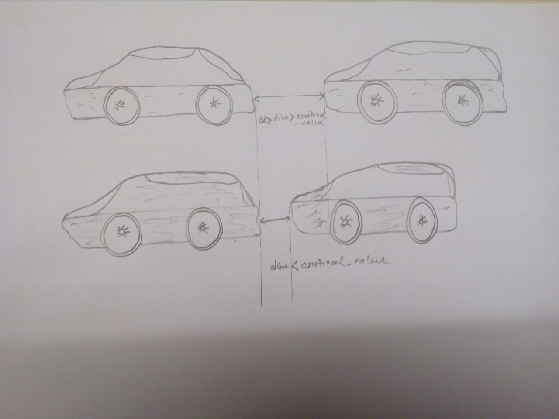

Figure: Vehicle Position

**Tools and Programming Language:**

We have used lejos operating system which is based on JAVA programming language. Eclipse is used as IDE. To install lejos, we have used Micro SD card which is greater than 2 GB and less than or equal to 32 GB.

As we mentioned earlier that due to some disadvantage of ultrasonic sensor and inaccuracies of mechanical design, the follower vehicle shows some immature behavior. One of them is that it changes the route in little angles. As a result the ultra sonic sensor can’t detect the first vehicle accurately. Another case is that the first vehicle is narrow, hence it also effects in measuring accurate distance by ultrasonic sensor.

**Reference:**

[1]

<http://www.rfwireless-world.com/Terminology/Advantages-and-disadvantages-of-Ultrasonic-Sensor.html>